Teaching and Learning Policy
Johnston Community Primary School
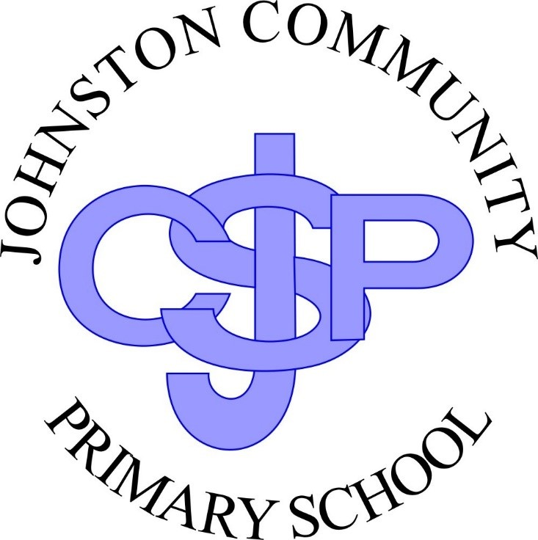

Curriculum intent – what are you trying to achieve through your curriculum?
• Curriculum design, coverage and appropriateness
Our values | Respect | Friendship | Excellence | Determination | Equality | Courage

Four Core Purposes | Enterprising, Creative Contributor | Ambitious Capable Learner | Healthy Confident Individual | Ethical Informed Citizen
Integral Skills | Creativity and innovation | Critical thinking and problem-solving | Personal effectiveness | Planning and organising
R.E.A.L Projects | Rigorous | Engaging | Authentic | Learning
What Matters Statements
Principles of Progression
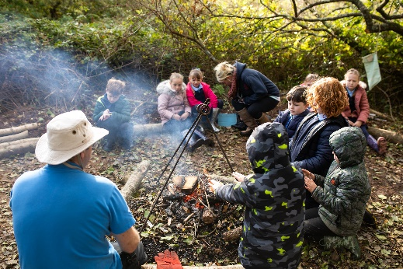
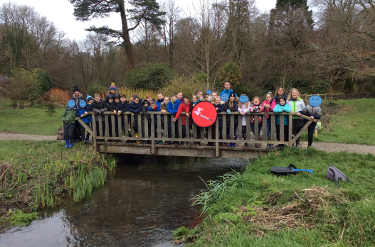
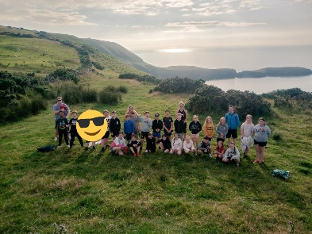
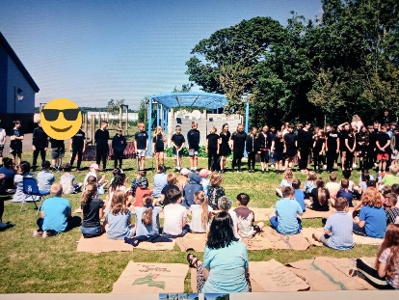

The Vision | A forward looking school that provides a nurturing environment for all, with a creative and engaging curriculum steeped in learning opportunities and experiences linked to real world matters encouraging all pupils to achieve their potential in everything they do. | To let our children be children. | To treat all our children as individuals and develop their individual personalities and interests as well as developing a respect and understanding of others. | To provide an environment where no child is left behind and all children can achieve their full potential both academically, physically, socially and emotionally. | To develop life skills through soft skills and values to ensure that children are prepared for their future lives and relationships.
 |  | To provide an inspirational modern and relevant curriculum where children develop soft skills across all curriculum areas underpinned by a core set of values. | To provide a truly inclusive curriculum where difference is celebrated and children are supported and nurtured. | To provide a relevant curriculum that is irresistible, unforgettable, based on practical, real life experiences. | 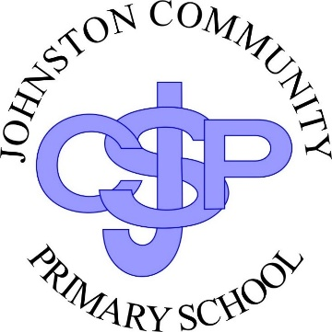
 |  | To be an inclusive school where we inspire and empower our children to learn. | To provide a stimulating, vibrant and exciting learning environment for all our children so that they feel happy and confident and are challenged to achieve excellence in everything they do. | To become the heart of the Johnston Community.

Implementation – How is the curriculum being delivered?
* Curriculum delivery * Teaching (pedagogy) * Assessment (formative and summative)

How do we ensure our intent is delivered? | Curriculum content is relevant to the school’s community and the wider world. | Knowledge is organised into small steps in order to ensure it supports subsequent learning. | Teachers ensure that learning is purposeful and clear so that children are motivated and see there is a purpose. | Enquiry based questions are used to stimulate children’s natural curiosity. | Discrete teaching of basic skills eg phonics, times table | Questioning, using blooms, is evident in all lessons, providing challenge to all children. | Teachers model high expectations. | Teachers know their children’s strengths, next steps and preferred learning style so that lessons are targeted and specific.
 | Challenge by choice is embedded to ensure there are no ceilings placed on the learning. | Children are empowered to make daily decisions about how and where they would like to learn. | Children can use their knowledge to improve their work and the work of others through critique. | Teachers monitor and assess children’s learning to ensure progression, consolidation and challenge in their learning. | Environmental stimuli, including trips and clubs, are used to enrich children’s experiences and engage them in their learning. | Curriculum teams monitor, moderate and provide support to ensure progression in skills and knowledge | Teachers use independent time to deliver targeted teaching to small groups of children or individuals.

R.E.A.L projects are planned to ensure there are opportunities for reasoning, analysis, critical thinking and problem solving, encompassing the national curriculum requirements. As a school, we work in teams to ensure there is a broad and balanced curriculum.
Real world context: Educational visits, visitors, assemblies, extra-curricular activities, links to charities, links to the local & wider community.
Inspire excellence; everyone, everyday!  All children, including those within vulnerable groups will achieve their targets.  ALN children’s needs are being fully met through support from targeted intervention, appropriate support from adults and, where necessary, support and advice from outside agencies.  We will be above national in the percentage of children achieving SAS in national tests.  An increasing percentage of children will achieve SAS above 115.  Children will have an in-depth knowledge of their learning and can use this to apply to other areas of the curriculum.  Children will have a deep love of reading and will be challenged to read as a writer.  Children will talk about their learning with enthusiasm and be able to link their learning to real life experiences.  The school will be central to the Johnston Community. | Our children will become independent learners, who have embedded our soft skills and values to ensure they can be:  Self-motivated problem solvers: ask questions and identify problems which need to be solved.  Self-confident: persevere; manage risks in order to master new skills, knowledge and concepts. Resist peer pressure by making independent informed decisions.  Self-reflective: identify misconceptions; assess progress; recognise misconceptions; evaluate experiences and identify next steps.  Empathetic: recognising emotions and motivations of self and others.  Communicators: confident communicators who are emotionally mature with a depth of language learning that enables them to share ideas effectively, including collaboratively.  Participate in discussion, dialogue and debate – actively listening to each other - explaining, describing and questioning and valuing their own and others’ contributions  Present ideas accurately through written and spoken forms. | Our children will know what it is to be a global citizen who:  respect the rights of others and are proactive in helping to make the world a better place to live in:  understand issues affecting themselves, the global community and the environment.  respect themselves, the global community and the environment.  are proactive - seeking to improve themselves, their community and the environment; using their empathy and knowledge of the world to make the appropriate choices.

